# Experiment # 14

Analyzing First RC Transient Circuit

# Objectives:

In this we will analyze first RC circuit using PSPICE software.

# Apparatus:

* A computer with PSPICE installed on it

# Procedure:

1. Open schematic program of PSPICE.
2. Click on the “Get New Part” button on the toolbar.
3. Type ‘r’ in the search bar and place the resistors on the white sheet.
4. Type ‘vdc’ in the search bar and place it on the white sheet.
5. Type ‘c’ in the search bar for capacitor and place it on the white sheet.
6. Type ‘switch’ in the search bar for switch (tclose=0) and place it on the white sheet.
7. Type ‘gnd-earth’ and place it on the white sheet.
8. Now arrange these components on the white sheet according to the circuit diagram as following.

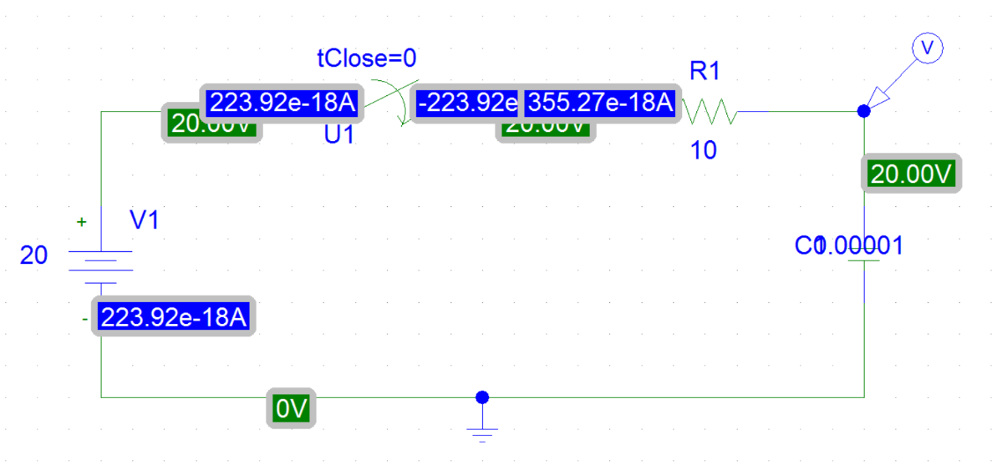

Figure 23 RC Circuit Diagram

1. Click voltage/level Marker button and place on the specified position in the circuit.
2. Now click Setup Analysis button.
3. A window will open check the transient box and then click on the transient button.
4. Set the Print step and final time to a suitable values.
5. Check the ‘skip initial transient solution’ box.
6. Click OK.
7. Now simulate the circuit by clicking the simulate button.
8. A graph will appear which will show the operation of your circuit. You can add more curves to your graph by clicking on Add trace button.

# Graph of circuit:

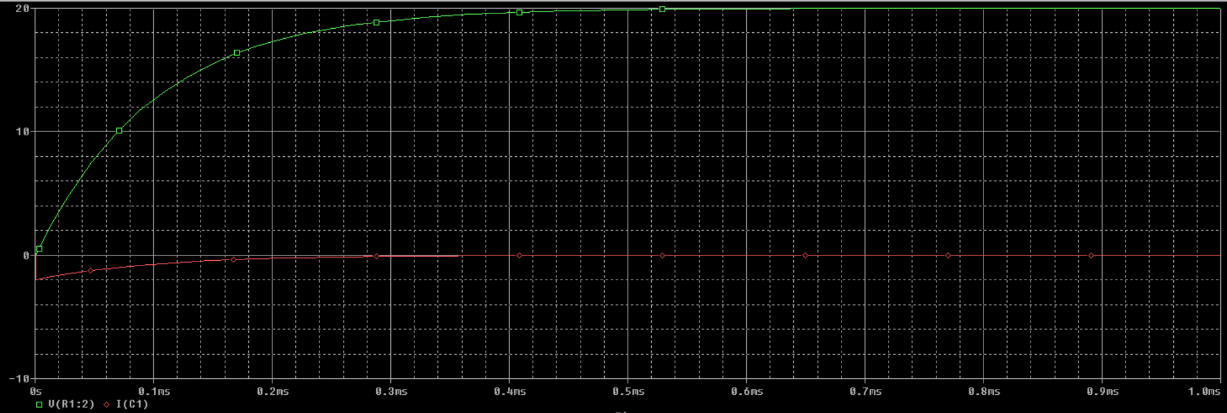

Figure 24 RC Circuit Graph